Ideation phase
Empathize& Discover
DATE | 31 January 2025
TEAM ID | LTVIP2025TMID30643
PROJECT NAME | Visualization tools for electric vehicle charge and range analysis
MAXIMUM MARKS | 2 marks

Empathy Map Canvas :
An empathy map canvas helps understand EV users’ needs, behaviors, and challenges when using visualization tools for charge and range analysis. It shows what users think, feel, see, and do while monitoring battery status, charging progress, and range prediction through dashboards and alerts.

This helps identify pain points like difficulty understanding EV data and unclear range estimation, as well as gains such as clear visual insights, accurate predictions, and better trip planning. It supports designing effective tools that improve user confidence and decision-making.
Example:
Reference: https://www.mural.co/templates/empathy-map-canvas
Empathy map

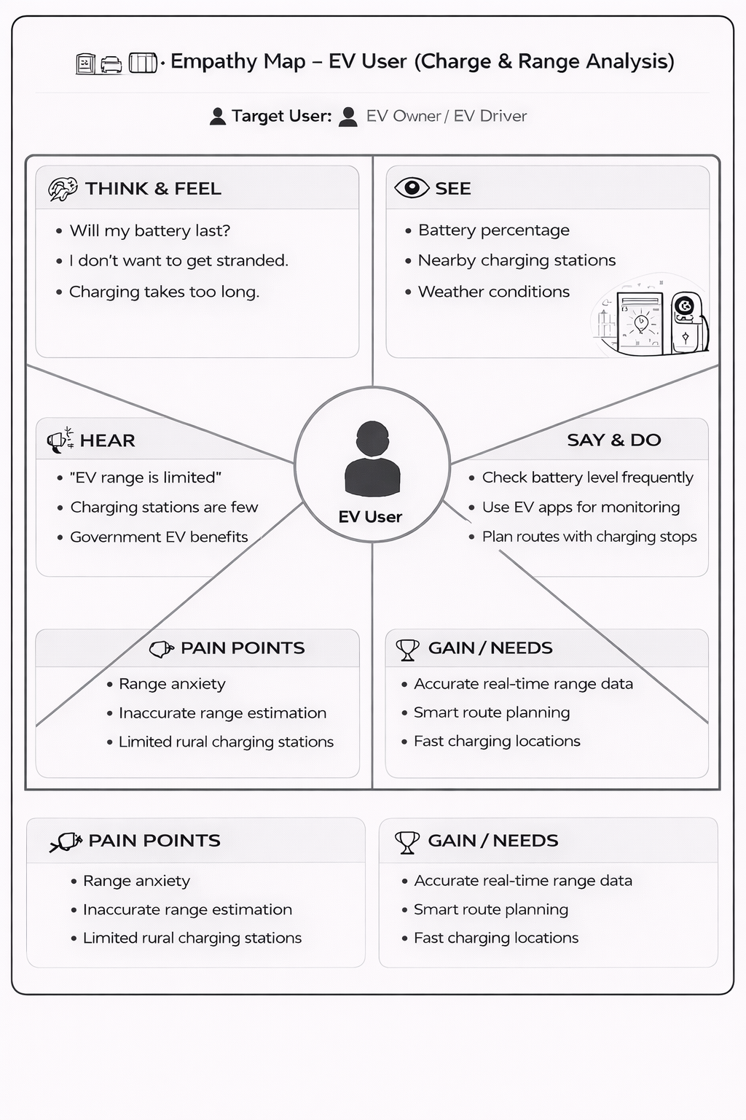
Example: